

Concordia Institute for Information System Engineering (CIISE) Concordia University

**INSE 6210: TOTAL QUALITY METHODOLOGIES IN ENGINEERING**

**PROJECT REPORT**

## **IMPROVING POSTAL SERVICE QUALITY OF PUROLATOR**

Submitted To:

## **Dr. ANJALI AWASTHI**

Submitted by:

|  |  |
| --- | --- |
| **STUDENT NAME** | **STUDENT ID** |
| Anjali Verma | 40110059 |
| Varinder Singh | 40086602 |
| Mohammed Faizan | 40131626 |
| Balkaran Singh Dhillon | 40111539 |
| Hari Ramasamy | 40094073 |

**CONTRIBUTION TABLE**

|  |  |  |
| --- | --- | --- |
| **Student Name** | **Student ID** | **Contribution Towards Project** |
| Anjali Verma | 40110059 | * Define phase * Project charter * SIPOC * Pareto Chart * CTQ’s * Process Map |
| Hari Ramasamy | 40094073 | * Measure phase * Dpmo calculation * R&R analysis * Process capability analysis * QFD * Lessons learnt from measure phase |
| Mohammed Faizan | 40131626 | * Analyze phase * Tree Diagram * Cause and effect Diagram * 5 whys technique * Matrix Data Analysis * Lessons learnt from analysis |
| Balkaran Singh Dhillon | 40111539 | * Improve phase * Improved Dpmo * Improved process capability * 5’s Technique * Profit Analysis * Lessons learnt from improved phase |
| Varinder Singh | 40086602 | * Control Phase * P chart * Scatter Diagram * Lesson Learnt * Website Design * Conclusion |

Final project report was prepared by everyone’s support, with each one typing their part and compiling those at the end at the group meeting coming up with conclusions and lessons learnt.

# **EXECUTIVE SUMMARY**

**Purolator is a leading integrated freight, package and logistics solutions provider, they have built one of Canada’s most extensive transportation and logistics networks and supporting infrastructure. The advantages of this size and scale benefit for their customers, with more facilities in more regional centers than any other freight and parcel solutions provider in Canada. Nationally, provincially and regionally, their customers can count on best-in-class service and support from Purolator, wherever they are.**

**They deliver services and solutions critical to Canada’s busiest urban centers. Purolator deliver promises. From timely, dependable package delivery to integrated distribution solutions, they are well-equipped with the size, experience and expertise to meet the sophisticated, high-volume demands of our customers and deliver their promises.**

**So, In the define phase we had consolidated on various feedback surveys from the customer to corner down on the main points of focus from customer view and understood the major CTQs to be on "Timeframe - Late Delivery" and "Customer Satisfaction - Low Index". Later the analyze phase helped us to identify the root cause impacting the major CTQ was due to “Military Management System". The measure phase calculated the current sigma level. Using Poka yoke method in the improve phase a way was identified in eliminating and improving key processes. Further in the control phase using various control charts we ensured whether our process is in place and serves the purpose.**

# **INTRODUCTION**

**This project concentrates to provide an overview of the current technological developments in the postal market and assess to the recent developments of digitalization etc. In Montreal, Postal services face problems such as poor authorization during delivery, less options with International services, product limitations for the shipping, customer service-based problems etc. We will be using a DMAIC approach to solve these issues and come up with a structured strategy in implementing the analyzed proposition.**

**Major problems with Purolator post.**

**· Labor relation problems**

**· Shipment Delays**

**· Efficiency Problems**

**· Innovational failures**

**DEFINE PHASE**

**Define Phase requires explaining the problem in a very specific manner that facilitate further analysis. The main purpose of this phase includes identifying the customers and the Critical to Quality (CTQ) parameters. We address project management issues such as what is needed to be done, who will do it and by what time and will do it by performing project scoping i.e. drilling down a project statement to a more specific problem etc.**

**PROJECT CHARTER:**

|  |  |
| --- | --- |
| **Project Name:** | **Improving the postal service quality of Purolator in Montreal** |
| **Executive Summary:** | **Postal services are very important these days as many important mails and parcels are being delivered by them. We have come up with certain solutions of the problems faced by them. We have followed DMAIC approach to understand and solve the issues.** |
| **Project Definition:** | |
| **The data will be collected from the published reviews and then after their analysis a master plan will be made to improve the Purolator.**  **The outcome: Customers will experience better services from Purolator and consequently it will have a positive impact on business.** | |
| **Vision:** | |
| **To provide customers quality postal services which means the parcels and mails should not be delayed and are never damaged and also we will try to provide some services that will add on to the customer service like customer is provided correct and precise tracking details.** | |
|  | |
| **Objectives:** | |
| **1. Measure the influence of the problem faced by Purolator and find the real time solutions.**  **2. Analyze the cause of the problem with the help of the various techniques like root cause and cause and effect analysis**  **3. Improve the process by applying the lessons learnt by analysis phase.**  **4. Control and Observe the process.**  **5. Find Critical to quality parameters and perform pareto analysis.** | |
| **Customers:** | |
| **Customers wants to send and receive their parcels and mails without any damage to them and also on correct time.** | |
| **Major Known Risks:** | |
| **Collection of data regarding the delivery times** | **Low** |
| **Finding real time problems faced by the company** | **Medium** |
| **Wrong database** | **Medium** |
| **Finding solutions** | **High** |
| **Stakeholders:** | |
| **Owner – Government, corporation etc.**  **Project Members-**  **Staff- Part time and full-time workers**  **Customers-** | |
| **Dependencies:** | |
| **DPMO calculation and R&R analysis are based on the data collection from the published reviews**  **Pareto chart development is dependent on CTQ parameters and its frequencies.** | |
| **Milestones:** | |
| **Items** | **Milestone** |
| **Define phase** | **28 September 2019 – 8 October 2019** |
| **Measure phase** | **9 October 2019 – 22 October 2019** |
| **Improve phase** | **23 October 2019- 30 October 2019** |
| **Analyze phase** | **31 October 2019- 13 November 2019** |
| **Control phase** | **14 November 2019- 19 November 2019** |
| **Deliverables:** | |
| **Items** | **Description** |
| **Define Phase** | **Project charter**  **SIPOC**  **Critical to Quality parameters**  **Process Map**  **Pareto chart** |
| **Measure Phase** | **DPMO Calculation**  **R&R**  **Process Capability analysis**  **QFD** |
| **Analyze Phase** | **Tree Diagram**  **Cause and effect Diagram**  **5 Whys Technique and Solutions**  **Matrix Data Analysis** |
| **Improve Phase** | **Improve process flow**  **Improve DPMO**  **Improve process capability** |
| **Control Phase** | **Control charts**  **Scatter Diagram** |
| **Communication strategy:** | |
| **1. Whenever one level is completed, a progress report will be submitted**  **2. Final report needs to be sent weekly or completion of any task** | |
| **Signature of team members:** | |
| **Anjali Verma** | Anjali verma |
| **Varinder Singh** | Varinder singh |
| **Mohammed Faizan** | Mohammed faizan |
| **Balkaran singh Dhillon** | Balkaran singh |
| **Hari Ramasamy** | Hari Ramasamy |

**SIPOC**

|  |  |  |  |  |
| --- | --- | --- | --- | --- |
|  |  |  |  |  |
| **Supplier** | **Input** | **Processes** | **Output** | **Customer** |
| **Packaging vendor** | **Parcels** | **Mails gathered and received at main office** | **Payment Confirmation** | **People who send and receive mail** |
| **Workplace provider** | **Government mails** | **Weights of mails are checked and organized** | **Delivery confirmation** | **Online customers** |
| **Banking services** | **Publications** | **Separation of heavy and light mails is done** | **Customer feedback** | **Government organizations** |
| **Transport provider** | **Letters** | **Transportation of mails via air or road** |  | **Retail customers** |
| **Packaging dealer** | **Bulk Mails** | **Mails sent to delivery team** |  |  |
| **Road carriers** |  | **Mails delivered** |  |  |
| **Employment team- full time and part time** |  |  |  |  |

**PROCESS MAP**

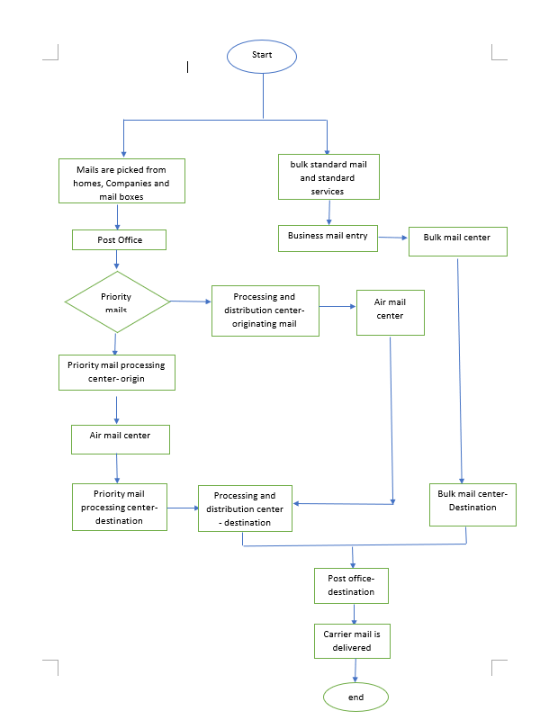

|  |  |  |  |  |  |  |  |  |  |  |  |  |  |  |  |  |  |  |  |  |  |  |  |  |  |  |  |  |  |  |  |  |  |  |  |  |  |  |  |  |  |  |  |  |  |  |  |  |  |  |  |  |  |  |  |
| --- | --- | --- | --- | --- | --- | --- | --- | --- | --- | --- | --- | --- | --- | --- | --- | --- | --- | --- | --- | --- | --- | --- | --- | --- | --- | --- | --- | --- | --- | --- | --- | --- | --- | --- | --- | --- | --- | --- | --- | --- | --- | --- | --- | --- | --- | --- | --- | --- | --- | --- | --- | --- | --- | --- | --- |
| **CRITICAL TO QUALITY PARAMETERS**  **After the mail was delivered successfully the feedback from the customers and the data from the reports were collected for the analysis to identify the key parameters that affected the delivery times. These are the Delivery Methods followed by Purolator delivery services. Data recorded below is per month.**     |  |  |  | | --- | --- | --- | | PUROLATOR | | | | Delivery Method | **Number of addresses**  **(In million)** | **% of total addresses** | | Home delivery (older & urban areas) | **4.3** | **27%** | | Rural mailboxes at the end of laneways | **4.0** | **26%** | | Post office boxes and general delivery mail | **5.1** | **32%** | | Community mailboxes | **1.8** | **11%** | | Lock boxes found in apartment buildings etc. | **0.7** | **4%** | | Total | **15.5** | **100%** |   **Workforce distribution:**   |  |  |  | | --- | --- | --- | | Workforce distribution | | | | Type of work | **% of workforce** | **Approx. Head count** | | Postmasters and assistants | **35%** | **17500** | | Rural and suburban mail delivery | **26%** | **13000** | | Mail processing | **15%** | **7500** | | Clerical, technical and professional | **10%** | **5000** | | Mail collection and delivery | **7%** | **3500** | | Supervisor and operational support | **5%** | **2500** | | Executive and management | 2% | 1000 | | Total | 100% | 50000 |   **From these data a table was generated to understand the critical to quality parameters and the frequencies of problem occurring was identified. This data was computed using the literature reviews done as well. From this data Pareto chart was developed to narrow down to find the major causes and understand on the main CTQ that required attention.** |  |
| **From the pareto chart we can see that 80% of the problems are caused by the Late deliveries, employee relation problems, Lack of experienced employees, broken parcels and supplier issues. We should take measures on these parameters initially and with this majority of problems will be resolved.** |  |

# **MEASURE PHASE**

This phase focuses on how to measure the internal processes that impact CTQs.

DPMO CALCULATION USING MONTHLY SERVICE DATA

Defects per million opportunities for the data given in table: Total number of defects = **1552**

Total number of opportunities for error = **12239**

Dpmo = (Number of defects discovered / Total number of opportunities) * 1000000

= (1552/ 12239) * 1000000

## = 126807.7

Sigma level = NORMSINV (1 – 126807.745/ 1000000) + 1.5

Sigma level = 2.641612

|  |  |  |
| --- | --- | --- |
| **Year** | **Number of Parcels Received to Deliver** | **Number of Parcels** Not **Delivered** |
| **1** | 410 | 78 |
| **2** | 355 | 79 |
| **3** | 438 | 66 |
| **4** | 427 | 68 |
| **5** | 418 | 31 |
| **6** | 447 | 17 |
| **7** | 427 | 57 |
| **8** | 394 | 65 |
| **9** | 426 | 57 |
| **10** | 351 | 31 |
| **11** | 415 | 37 |
| **12** | 439 | 68 |
| **13** | 376 | 12 |
| **14** | 439 | 28 |
| **15** | 409 | 42 |
| **16** | 427 | 51 |
| **17** | 447 | 69 |
| **18** | 395 | 63 |
| **19** | 385 | 61 |
| **20** | 385 | 21 |
| **21** | 389 | 71 |
| **22** | 360 | 61 |
| **23** | 369 | 32 |
| **24** | 374 | 25 |
| **25** | 442 | 71 |
| **26** | 398 | 63 |
| **27** | 420 | 79 |
| **28** | 427 | 37 |
| **29** | 410 | 80 |
| **30** | 440 | 32 |
| **TOTAL** | 12239 | 1552 |

*Table 4 DPMO Calculation*

**R&R ANALYSIS**

We have considered 2 business days as minimum and 5 business days as maximum to deliver a mail item successfully. In the table below, we have taken three different operators for two trials for handling ten mail items.

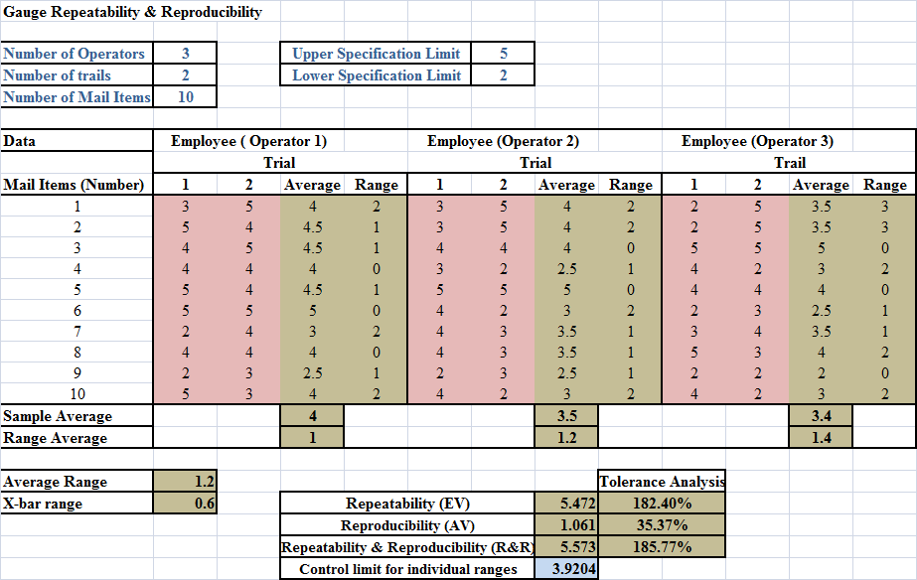

From the above R&R analysis, the values of EV, AV and R&R are 182.40%, 35.37% and 185.77% respectively. All values are above the acceptable limit. So, we have to proceed with six sigma to bring the value under an acceptable limit.

**PROCESS CAPABILITY**

The Process Capability Analysis was done by collecting the delivery time averages over the last 15 years from 5 Random postal Business Unit. From the data and Cp computation, it is found that Cpk < 1 which indicates that the process is not capable.

|  |  |  |  |  |  |
| --- | --- | --- | --- | --- | --- |
| **Nominal Specification** | **3.5** | **Average** | **3.52** | **Cp** | **0.528665** |
| **Upper Specification**  **Limit** | **5** | **Standard Deviation** | **0.945779** | **Cpu** | **0.521616** |
| **Lower Specification Limit** | **2** | **Cpl** | **0.535714** |
| **Cpk** | **0.521616** |

*Table 5 Process Capability Analysis*

|  |  |  |  |  |  |
| --- | --- | --- | --- | --- | --- |
| **DATA** | **BU 1** | **BU 2** | **BU 3** | **BU 4** | **BU 5** |
| **2003** | 4 | 2 | 2 | 3 | 3 |
| **2004** | 5 | 5 | 5 | 3 | 3 |
| **2005** | 2 | 3 | 4 | 5 | 5 |
| **2006** | 2 | 4 | 3 | 4 | 2 |
| **2007** | 4 | 5 | 4 | 4 | 3 |
| **2008** | 4 | 4 | 4 | 2 | 2 |
| **2009** | 5 | 4 | 5 | 4 | 4 |
| **2010** | 3 | 2 | 4 | 4 | 3 |
| **2011** | 2 | 5 | 2 | 3 | 3 |
| **2012** | 3 | 4 | 5 | 3 | 4 |
| **2013** | 2 | 5 | 3 | 2 | 5 |
| **2014** | 3 | 3 | 3 | 3 | 2 |
| **2015** | 4 | 5 | 5 | 5 | 4 |
| **2016** | 3 | 3 | 3 | 5 | 5 |
| **2017** | 2 | 4 | 2 | 2 | 4 |

*Table 6 Data for Process Capability*

**QUALITY FUNCTION DEPLOYMENT (QFD)**

House of Quality or QFD is a tool used to determine the relationship between the customer requirements and the technical requirements. Technical requirements are designed based on the customer requirements which are obtained from the CTQs.

In QFD the individual weights are assigned to the customer requirements respective to the technical requirements through which the raw score and relative ranking of technical requirements are calculated.

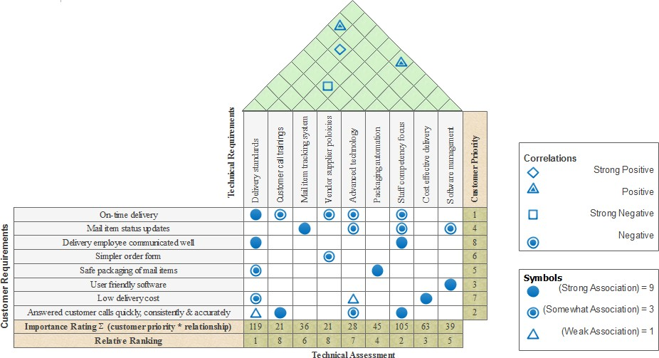

*Figure 6 QFD Analysis*

**ANALYZE PHASE**

Analyze is the third phase of DMAIC process. It is a deterministic stage that yields optimum output of the solution. It focuses on processes, facts and information to gain an understanding of why defects, errors or excessive variation occurs and finding opportunities for improvement. It involves developing flow charts, charting data, conducting experiments to verify hypothesized relationships. To tackle the variations in postal services, we are using cause and effect analysis and 5 whys technique.

The 4 tools that we are using for Analyze phase are -

1. Tree Diagram
2. Cause and Effect diagram
3. 5 Whys technique
4. Matrix Data Analysis

**Tree Diagram**

Tree Diagram helps to organize facts and ideas which have an affinity for each other into categories. It is a powerful technique for grouping and understanding the data.

We have used Tree diagram in this project to organize general information and consolidate information with respect to the criticality and complexity. The information gathered in the affinity diagram can be further used for other analyze phase techniques such as the Cause and Effect diagram and 5 Whys technique.

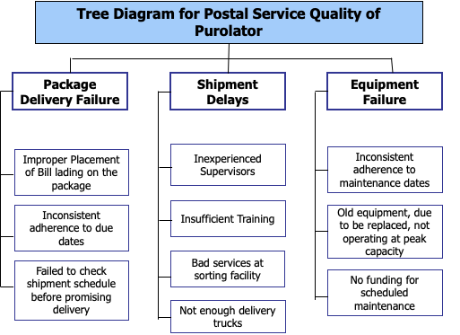

Figure 1: Tree Diagram for Postal Service Quality of Purolator

**Cause and Effect diagram**

The most common Analyze phase tool used is the fishbone diagram or the Ishikawa diagram. The Ishikawa diagram is a graphical representation of expected problems which can be identified with the causes and effects related to it. The tool is mainly used to stimulate the reasoning during brainstorming. The root cause can be the quality of service in Purolator that is leading the major impact and the Causes are listed as follows with the following effects.

1. Shipment Delays
2. Package Delivery Failure

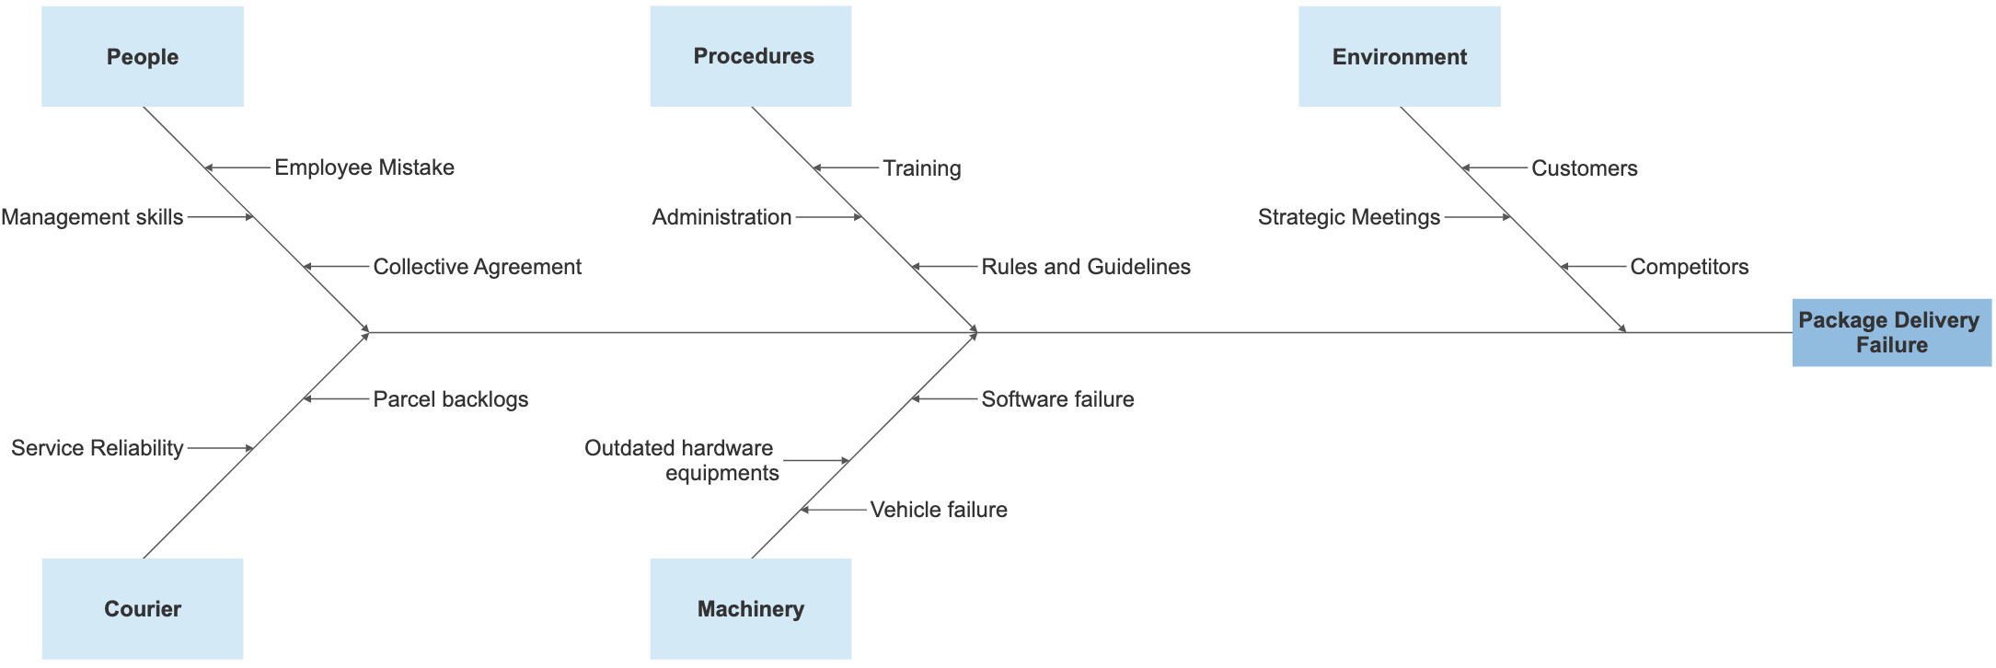

Figure 2: Ishikawa Diagram for Package Delivery Failure

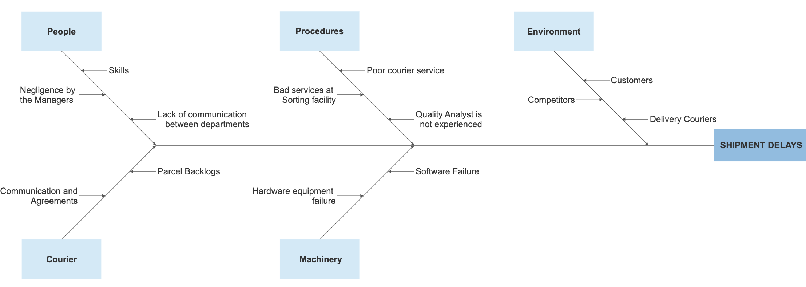

Figure 3: Ishikawa Diagram for Shipment Delays

**Root Cause Analysis**

Root cause analysis will help you to identify the actual cause in the data. It also helps in identifying the relationship between causes that occur. It also helps in finding the data without any statistical analysis this type of problem is driven by changes in behavior, process, measures, equipment or materials.

The 5 Whys technique is a simple brainstorming method that is used by a quality improvement team to identify the root cause(s) of a problem. Upon finding a problem either by Ishikawa diagram or process mapping, ask “why” question to identify the root causes of the problem.

|  |  |
| --- | --- |
| **5 Why Question Table (Problem #1)** | |
| **PROBLEM: Package not delivered to the Receiver** | |
| **Why Question?** | **Answers** |
| Why was the package not delivered to the Receiver? | Because of the Zero Delivery Attempts by the Driver. |
| Why there is a Zero Delivery Attempts by the Driver? | Because the driver was not able to scan or read the receiver’s details. |
| Why was the driver not able to scan or read the receiver’s details? | Because of improper placement of bill of lading on the package. |
| Why there is improper placement of bill of lading on the package? | Because the initial shipment was not properly examined by the Purolator Employee. |
| Why was the initial shipment was not properly examined by the Purolator Employee? | Because the Upper Management did not provide specific guidelines to the Purolator Drop Shipment Employees. |
| **Recommended Solution:** 1. Proper rules and guidelines should be made available to the Employees of Purolator postal service.  2. The employee must be trained to verify whether the package is fit for the shipment. | |

|  |  |
| --- | --- |
| **5 Why Question Table (Problem #2)** | |
| **PROBLEM: Shipment delays in Purolator** | |
| **Why Question?** | **Answers** |
| Why there is a delay in shipment? | Due to the delay in dispatching of orders at the Sort Facility. |
| Why there is a delay in dispatching of orders at the Sort Facility? | Because of the Sort Tunnel at the Processing Centre did not scan the package correctly. |
| Why did the Sort Tunnel at the Processing Centre did not scan the package correctly? | Because of the Sort Tunnel can scan only 5 sides of the package and the barcode was on the 6th side of the package and was hidden. |
| Why was 6th side of the package hidden? | Because the packages were poorly organized on the conveyor belt by the Workers. |
| Why the packages are poorly organized on the conveyor belt by the Workers? | Because of untrained staff in Purolator Processing Centre. |
| **Recommended Solution:** 1. The Managers must make sure that the employed staff are trained, and also proper training must be given to new staff.  2. The Sort Tunnel machine must be upgraded in a cost-effective way to scan all dimensions of the at the package. | |

**Matrix Data Analysis**

|  |  |  |  |  |  |  |
| --- | --- | --- | --- | --- | --- | --- |
| **Persons Involved** |  |  |  |  |  | **TOTAL** |
| Driver | ⚫ |  | ◯ |  |  | 12 |
| Supplier | ◯ | ◯ | ⚫ |  |  | 15 |
| Counter Staff |  | ⚫ | △ |  |  | 10 |
| General Manager | △ | ◯ | △ | ⚫ | ◯ | 17 |
| IT Specialist |  | △ |  |  | ⚫ | 10 |
| **Options** | Delayed Delivery | Bill Lading Error | Damaged Parcels | Training | Website Design |  |

⚫ - HIGH - 9 - (Prime Responsibility)

◯ - MEDIUM - 3 - (Secondary Responsibility)

△ - LOW - 1 - (Kept Informed)

Figure 4: Responsibility Matrix Analysis Diagram for Purolator.

**IMPROVE PHASE**

This stage focuses on removing or resolving the problem and improving the performance measures of the Critical to Quality parameters. Issue arrangement frequently involve specialized or organizational changes.

**IMPROVE USING AFFINITY DIAGRAM**

**Affinity Diagram**

Affinity Diagram helps to organize facts and ideas which have an affinity for each other into categories. It is a powerful technique for grouping and understanding the data.

We have used Affinity diagram in this project to organize general information and consolidate information with respect to the criticality and complexity. The information gathered in the affinity diagram can be further used for other analyze phase techniques such as the Cause and Effect diagram and 5 Whys technique.

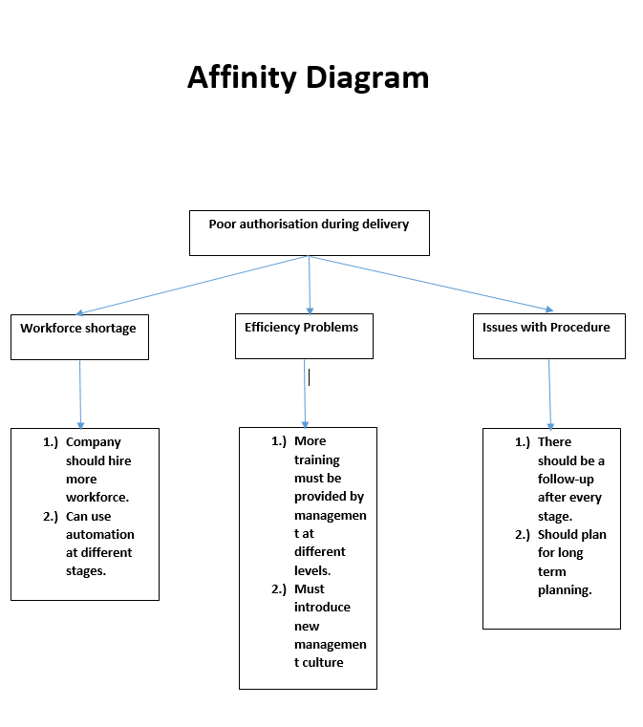

**IMPROVE USING 5’S TECHNIQUE**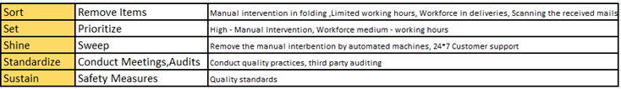

*Figure 1) 5's Technique*

**IMPROVED DPMO**

After using the 5’s technique and by sorting with the issues recognized by analysis phase it is accepted that the delivery time of the package gets improved and reduce to some extent which in-case increase the sigma level and reduce the DPMO level.

The improved sigma level is 3.37

The improved data willbe as follows

|  |  |  |
| --- | --- | --- |
| **Year** | **Number of Parcels Received to Deliver** | **Number of Parcels Not Delivered** |
| **1** | 410 | 38 |

|  |  |  |
| --- | --- | --- |
| **2** | 355 | 29 |
| **3** | 438 | 26 |
| **4** | 427 | 18 |
| **5** | 418 | 11 |
| **6** | 447 | 17 |
| **7** | 427 | 17 |
| **8** | 394 | 15 |
| **9** | 426 | 17 |
| **10** | 351 | 11 |
| **11** | 415 | 10 |
| **12** | 439 | 8 |
| **13** | 376 | 2 |
| **14** | 439 | 9 |
| **15** | 409 | 12 |
| **16** | 427 | 11 |
| **17** | 447 | 12 |
| **18** | 395 | 3 |
| **19** | 385 | 4 |
| **20** | 385 | 11 |
| **21** | 389 | 10 |
| **22** | 360 | 11 |
| **23** | 369 | 12 |
| **24** | 374 | 15 |
| **25** | 442 | 11 |
| **26** | 398 | 12 |
| **27** | 420 | 9 |
| **28** | 427 | 7 |
| **29** | 410 | 8 |
| **30** | 440 | 2 |
| **TOTAL** | **12239** | **378** |
|  |  |  |
| Defects per million opportunities for the generated data**:** | | |
| Total number of defects = 378 | | |
| Total number of opportunities = 12239 | | |
| Formula used: | | |
|  | | |
| Defects/ Opportunities = 378/12239 = 0.03088487 | | |
| DPMO = (Defects/ Opportunities) *1000000 = (378/12239) *1000000 = 30884.87 | | |
|  | | |
| k= NORMSINV (1-DPMO/1000000) +SHIFT | | |
| k = NORMSINV (1-0.03088487) + 1.5 | | |

|  |
| --- |
| k = 1.87 + 1.5 |
| k = 3.37 |
| Sigma level = 3.37 |

Figure 2) Improved DPMO

**IMPROVED PROCESS CAPABILITY**

After our improvements, we measure the Process Capability Index and we found our Cpk > 1 which evidently shows that our process is very much stable than before.

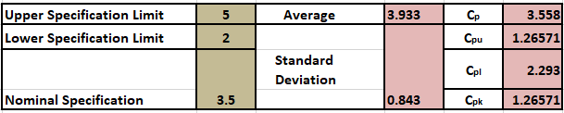

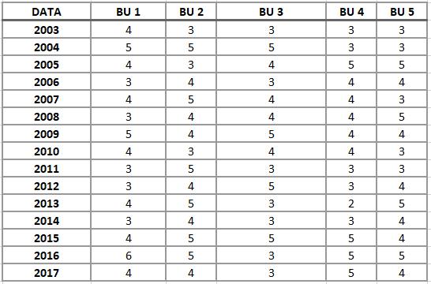

**APPROXIMATED PROFIT ANALYSIS**

|  |  |  |
| --- | --- | --- |
| **Profit Raise (Annual)** | | |
|  |  |  |
| **Before Six Sigma** | **After Six sigma** |
|  |  |  |
| **No of Conformities** | **12239-1552=10687** | **12239-378=11861** |
|  |  |  |
| **Fixed cost** | **$100,000** | **$100,000** |

|  |  |  |
| --- | --- | --- |
| **Delivery Price for Third Party Vendor** | **50$** | **50$** |
| **Average cost of all deliveries\*** | **35$** | **28$** |
|  |  |  |
| **Profit\*** | **260305** | **360942** |
| **Six Sigma Investment Cost (SSIC)= $40000** | | |
| **Profit including Six Sigma cost = $360942 – SSIC = $320942** | | |
| **Net Profit = Profit with Six Sigma as Investment – Profit before Six Sigma implementation** | | |
| **= $320942 – $260305** | | |
| **= $60637** | | |

Figure 3) Profit Analysis

Delivery price for third party vendor* - Average delivery price hand over to the third-party vendors.

Average cost of all deliveries* - Average cost of all the deliveries handled.

Profit* - [(Delivery price for third party vendor) *(No. of Orders placed)]-[[(Average cost of all deliveries)*(No. of Orders placed)] + [Fixed Cost]]

# **CONTROL PHASE**

Control Phase is the last phase of DMAIC model. The main focus of this phase focuses on how to maintain the improvements over time. This can include establishing the new standards and procedures, training the workforce and instituting controls like checklists, periodic status reviews, statistical process control charts etc. The main tool used in Control Phase is Control charts.

We are considering a data sets which consist of the number of parcel the Purolator got to deliver and number of problems they encountered and then we are performing p-chart analysis to check the control of the process before and after the application of six sigma.

## **P-CHART BEFORE SIX SIGMA**

## 

|  |  |  |  |  |  |  |
| --- | --- | --- | --- | --- | --- | --- |
| Days | **Number of parcels are received to deliver** | **Number of problems related to parcel** | CL | P Bar | UCL | LCL |
| 1 | 353 | 67 | 0.189802 | 0.13356 | 0.187878 | 0.079242 |
| 2 | 364 | 53 | 0.145604 | 0.13356 | 0.187051 | 0.080069 |
| 3 | 443 | 74 | 0.167043 | 0.13356 | 0.182047 | 0.085073 |
| 4 | 433 | 35 | 0.080831 | 0.13356 | 0.182604 | 0.084516 |
| 5 | 407 | 61 | 0.149877 | 0.13356 | 0.184146 | 0.082974 |
| 6 | 386 | 71 | 0.183938 | 0.13356 | 0.185504 | 0.081616 |
| 7 | 441 | 46 | 0.104308 | 0.13356 | 0.182157 | 0.084963 |
| 8 | 436 | 16 | 0.036697 | 0.13356 | 0.182435 | 0.084685 |
| 9 | 366 | 67 | 0.18306 | 0.13356 | 0.186904 | 0.080216 |
| 10 | 426 | 76 | 0.178404 | 0.13356 | 0.183005 | 0.084115 |
| 11 | 354 | 58 | 0.163842 | 0.13356 | 0.187801 | 0.079319 |
| 12 | 366 | 76 | 0.20765 | 0.13356 | 0.186904 | 0.080216 |
| 13 | 381 | 38 | 0.099738 | 0.13356 | 0.185844 | 0.081276 |
| 14 | 378 | 26 | 0.068783 | 0.13356 | 0.186051 | 0.081069 |
| 15 | 441 | 61 | 0.138322 | 0.13356 | 0.182157 | 0.084963 |
| 16 | 390 | 49 | 0.125641 | 0.13356 | 0.185237 | 0.081883 |
| 17 | 439 | 33 | 0.075171 | 0.13356 | 0.182267 | 0.084852 |
| 18 | 443 | 67 | 0.151242 | 0.13356 | 0.182047 | 0.085073 |
| 19 | 406 | 61 | 0.150246 | 0.13356 | 0.184208 | 0.082912 |
| 20 | 393 | 65 | 0.165394 | 0.13356 | 0.185039 | 0.082081 |
| 21 | 411 | 37 | 0.090024 | 0.13356 | 0.183899 | 0.083221 |
| 22 | 419 | 75 | 0.178998 | 0.13356 | 0.183416 | 0.083703 |
| 23 | 357 | 42 | 0.117647 | 0.13356 | 0.187572 | 0.079547 |
| 24 | 408 | 37 | 0.090686 | 0.13356 | 0.184084 | 0.083036 |
| 25 | 406 | 10 | 0.024631 | 0.13356 | 0.184208 | 0.082912 |
| 26 | 439 | 80 | 0.182232 | 0.13356 | 0.182267 | 0.084852 |
| 27 | 400 | 80 | 0.2 | 0.13356 | 0.184587 | 0.082533 |
| 28 | 380 | 30 | 0.078947 | 0.13356 | 0.185912 | 0.081208 |
| 29 | 416 | 57 | 0.137019 | 0.13356 | 0.183596 | 0.083524 |
| 30 | 380 | 63 | 0.165789 | 0.13356 | 0.185912 | 0.081208 |
|  | 12062 | 1611 |  |  |  |  |

***Table 11 Computation for P-chart before six-sigma***

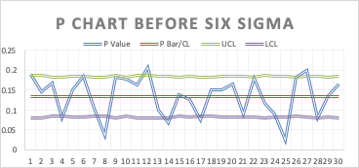

***Figure 8 P-Chart before six-sigma***

**Almost 7 days in a month are found to be out of control before the application of the six sigma. This is not normal, and the process is way out of control**

## **P-CHART AFTER SIX SIGMA**

**After the application of six sigma the process seems to be in control and has improved much more compared to the previous scenario.**

|  |  |  |  |  |  |  |  |
| --- | --- | --- | --- | --- | --- | --- | --- |
| **Day** | **No of parcels received to deliver** | **No of parcels not delivered** | **P-Bar/CL** | **SD** | **P value** | **LCL** | **UCL** |
| **1** | 510 | 10 | 0.030 | 0.007661 | 0.019608 | 0.007818 | 0.053782 |
| **2** | 455 | 15 | 0.030 | 0.008111 | 0.032967 | 0.006468 | 0.055132 |
| **3** | 450 | 16 | 0.030 | 0.008156 | 0.035556 | 0.006333 | 0.055267 |
| **4** | 427 | 5 | 0.030 | 0.008372 | 0.01171 | 0.005683 | 0.055917 |
| **5** | 340 | 12 | 0.030 | 0.009383 | 0.035294 | 0.002652 | 0.058948 |
| **6** | 447 | 17 | 0.030 | 0.008183 | 0.038031 | 0.006251 | 0.055349 |
| **7** | 427 | 12 | 0.030 | 0.008372 | 0.028103 | 0.005683 | 0.055917 |
| **8** | 394 | 15 | 0.030 | 0.008716 | 0.038071 | 0.004652 | 0.056948 |
| **9** | 426 | 17 | 0.030 | 0.008382 | 0.039906 | 0.005654 | 0.055946 |
| **10** | 351 | 11 | 0.030 | 0.009234 | 0.031339 | 0.003097 | 0.058503 |
| **11** | 400 | 13 | 0.030 | 0.00865 | 0.0325 | 0.004849 | 0.056751 |
| **12** | 439 | 9 | 0.030 | 0.008257 | 0.020501 | 0.006029 | 0.055571 |
| **13** | 376 | 13 | 0.030 | 0.008922 | 0.034574 | 0.004034 | 0.057566 |
| **14** | 439 | 9 | 0.030 | 0.008257 | 0.020501 | 0.006029 | 0.055571 |
| **15** | 409 | 15 | 0.030 | 0.008555 | 0.036675 | 0.005136 | 0.056464 |
| **16** | 427 | 12 | 0.030 | 0.008372 | 0.028103 | 0.005683 | 0.055917 |
| **17** | 447 | 17 | 0.030 | 0.008183 | 0.038031 | 0.006251 | 0.055349 |
| **18** | 372 | 5 | 0.030 | 0.00897 | 0.013441 | 0.00389 | 0.05771 |
| **19** | 385 | 15 | 0.030 | 0.008817 | 0.038961 | 0.004348 | 0.057252 |
| **20** | 385 | 11 | 0.030 | 0.008817 | 0.028571 | 0.004348 | 0.057252 |
| **21** | 389 | 10 | 0.030 | 0.008772 | 0.025707 | 0.004485 | 0.057115 |
| **22** | 360 | 16 | 0.030 | 0.009118 | 0.044444 | 0.003445 | 0.058155 |
| **23** | 369 | 12 | 0.030 | 0.009006 | 0.03252 | 0.003781 | 0.057819 |
| **24** | 360 | 15 | 0.030 | 0.009118 | 0.041667 | 0.003445 | 0.058155 |
| **25** | 390 | 11 | 0.030 | 0.00876 | 0.028205 | 0.004519 | 0.057081 |
| **26** | 398 | 12 | 0.030 | 0.008672 | 0.030151 | 0.004784 | 0.056816 |
| **27** | 420 | 9 | 0.030 | 0.008442 | 0.021429 | 0.005475 | 0.056125 |
| **28** | 427 | 17 | 0.030 | 0.008372 | 0.039813 | 0.005683 | 0.055917 |
| **29** | 400 | 8 | 0.030 | 0.00865 | 0.02 | 0.004849 | 0.056751 |
| **30** | 420 | 19 | 0.030 | 0.008442 | 0.045238 | 0.005475 | 0.056125 |
| **TOT** | **12239** | **378** |  |  |  |  |  |

***Table 12 Computation for P-chart after six-sigma***

*Figure 9 P-Chart after six-sigma*

# **SCATTER PLOT**

# 

# ***Figure 10 Scatter Plot before six-sigma***

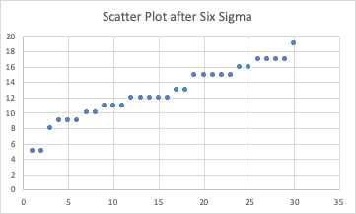

***Figure 11 Scatter Plot After six-sigma***

# **WEBSITE DESIGN**

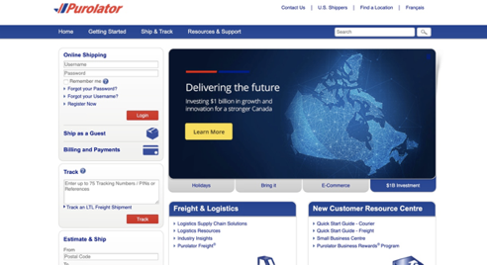

# **The Website design of Purolator is not user friendly and It should have more features. The response time of the website is slow.**

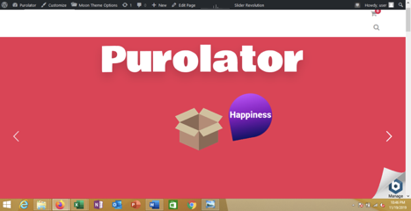

# **CONCLUSION**

* The application of DMAIC methodology has shown positive results by identifying the key issues and solving them using total quality methodologies.

    • The study from the Purolator postal service showed that even though the process is out of control for more than 50 percentage, it can be brought to control by the implementation of six sigma through various techniques at various levels.

    • DPMO, Process capability were all improved and brought into control by using 5’s technique in the improved phase.

Some of the wastages removed by implementing 5’s technique in the improved phase is as follows

* Transportation – not handling the packages properly.
* Waiting – time delays or idle time
* Over-processing – unnecessary processing steps
* Not using human resources – not implementing the ideas / suggestions of employees
* Motion – actions of people that do not add value
* The workers have a lack of Confidence.

# 

# **LESSONS LEARNT**

# **Quality Improvement is important throughout the lifecycle of the project and has an huge impact on its performance over a longer run.**

* **Six sigma methodologies and its implementation improve the project success rate and decreases uncertainties.**
* **Risk of project failure is decreased or avoided by direct implementation of six sigma processes.**
* **Changes, issues, problems and any differences in the project must be immediately attended and corrected for proper working of the project.**
* **Total Quality Methodology has a positive effect on employee satisfaction, customer satisfaction, product quality and project success etc.**
* **Six sigma methodologies and its implementation improve the project success rate and decreases uncertainties.**
* **Risk of project failure is decreased or avoided by direct implementation of six sigma processes.**
* **Changes, issues, problems and any differences in the project must be immediately attended and corrected for proper working of the project.**
* **Total Quality Methodology has a positive effect on employee satisfaction, customer satisfaction, product quality and project success etc.**

# **REFERENCES**

# [**www.smartdraw.com**](http://www.smartdraw.com) **which is to cause and Effect diagrams.**

* [**https://ca.trustpilot.com/review/www.purolator.com**](https://ca.trustpilot.com/review/www.purolator.com)

# **Lecture Notes from 1-8**

* [**https://www.quora.com/What-is-the-difference-between-Purolator-FedEx-USPS-and-DHL**](https://www.quora.com/What-is-the-difference-between-Purolator-FedEx-USPS-and-DHL)
* **·**  [**http://blog.proqc.com/simplified-5s-what-is-it-why-is-it-important/**](http://blog.proqc.com/simplified-5s-what-is-it-why-is-it-important/)
* [**http://forums.redflagdeals.com/purolator-messed-up-missed-delivery-notice-big-time-1043542/**](http://forums.redflagdeals.com/purolator-messed-up-missed-delivery-notice-big-time-1043542/)
* **Exploring Community Cohesion in Rural Canada Post-Extreme Weather: Planning Ahead for Unknown Stresses Laycock, K.E.Caldwell, University of Waterloo, University of Guelph**
* [**https://www.n49.com/biz/304799/purolator-on-ottawa-3330-hawthorne rd/?page=zBiqGLa**](https://www.n49.com/biz/304799/purolator-on-ottawa-3330-hawthorne%20rd/?page=zBiqGLa)